**LETTERKENNY INSTITUTE OF TECHNOLOGY**

**ASSIGNMENT COVER SHEET**

Lecturer’s Name: Martin Robinson

Assessment Title:  **Deliverable 2 UML Documentation**

Work to be submitted to:  **Helen McMahon**

Date for submission of work:  **20/12/2017**

Place and time for submitting work:

**To be completed by the Student**

Student’s Name:  **Abidemi Aderinto, James Fallon, Mukul Hasan, Robert Shally**

Class:  **BSC Computing**

Subject/Module:  **Team Project**

Word Count (where applicable):

I confirm that the work submitted has been produced solely through my own efforts.

Student’s signature: Date:  **07/02/2018**

**Team Project**

**Deliverable 2 UML Documentation**

**Table of Contents**

Use Case…………………………………………………………………………………………………….4

Class Diagram…………………………………………………………………………………………….5

Sequence Diagram …………………………………………………………………………………….6

Behavioural State Diagrams…………..………………………………………………………….8

**Use Case**

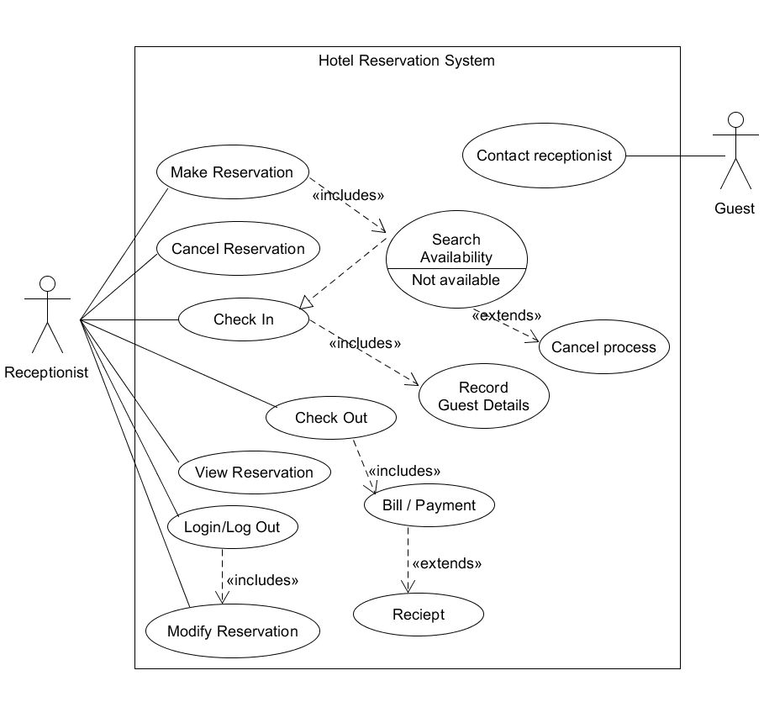

**Class Diagram**

Class diagram image is attached long with deliverables called ClassDiagram.png (Better resolution) as it was too big to fit on screen.

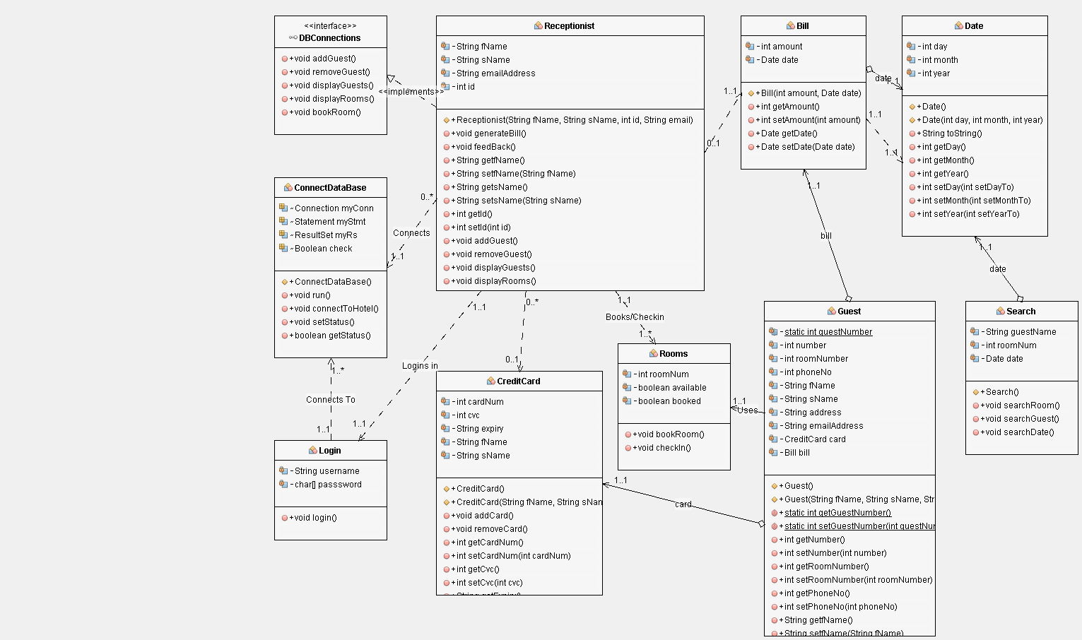

**Sequence Diagram**

**Main Page**

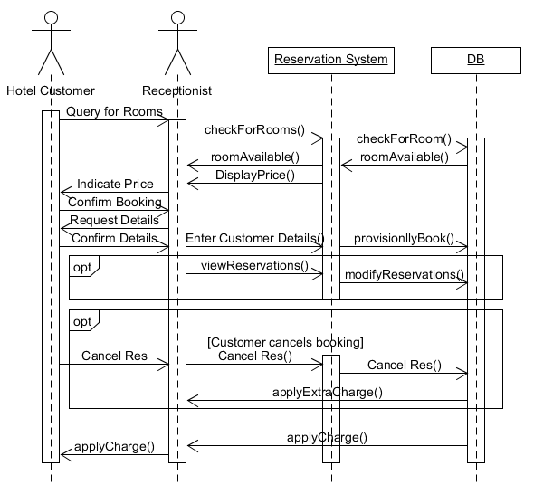

**Log-On Page**

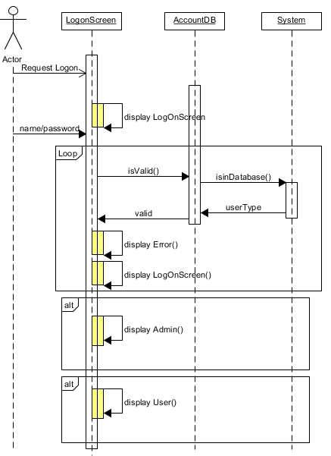

**Behavioural State Diagrams**

